

**Lethbridge Fish and Game Association [LFGA]**

**Shooting Sports Facility**

**Archery Range Report**

**Introduction**

The LFGA Archery range programs were more successful in 2024 compared to previous years. A number of general programs were run in 2024 and some were done in conjunction with schools and other archery clubs [Bowbenders]. We offered learn to shoot classes, fun events and 3D competitions. In addition, our range officers assist many new archers in teaching form and ensuring proper conduct and safety experienced at the range. There is a strong safety element in terms of appropriate equipment care and usage that is monitored by our volunteers.

**Not so fun fact.**

**Did you know; that a damaged arrow can explode in a compound bow. The result can be both a destroyed bow and can cause serious injury to the archer with carbon arrow shards being driven into arms and fingers.**

**General**

The LFGA archery range has been very successful, however with success comes additional usage. In 2024 we introduced and trained over 600 new shooters to archery. With this number of beginners, we have had a heavy usage on our bows/arrows and targets. In addition, our 3D targets in most cases are old and at the end of their lifespan. In addition, we have noted a significant increase in our daily drop in use on our white foam targets and our 3D range as compared to previous years.

**Education**

LFGA Archery provides a multifaceted approach to education in the sport of archery. Listed is an overview of the elements of our programming. Our top four archery volunteers have Coaching and Judging designations.

* Equipment Safety. Participants are taught the dangers of a bow and arrow.
* Range Safety. Ensuring all protocols on the range are adhered to.
* Style and Form. There is a 12-step program integrated with relaxation and discipline simultaneously.
* Hunting. We teach ethics of good hunting and what is an ethical shot.
* Practise. In our 3D program participants get to practise their hunting skills and learn to work within their limitations.
* Fun. We teach fun, participants of all ages love ballons, we do special events and fun pop-up events.

**In essence archery is fun, addictive and educational in a myriad of ways.**

1. **2024 Archery Education Programs**

The following programs were offered in 2024.

* Youth Target Archery – Compound Bows run by a National Team Coach [Free]
* Pop Up Special Events for Adult and Youth for both members and the public at large– Run by our Coaches and Key Volunteers [Free]
* 3D Fun Night- A $10 charge for adults and youth [Free]
* School Classes- Free use of equipment and free instruction
* Individual Instruction– Free for new beginning LFGA archers

**Individually our archers did very well in tournaments, we had a winner in a provincial sanctioned shoot. Top 10s in local competitions.**

1. **Participation**

Based on observation and comparisons to other archery clubs there are approximately 250+ archers who use the range.

1. **Types of Equipment Provided**

LFGA provides recurve bows of varying draw weights for the general public. Our bows fit most youth and adults. We also provide bows, arrows, armguards and bow stringers. One of our big costs are arrows, as they get damaged by people missing targets or get lost in the grass on the berms that are used as backstops for 3D archery. We also provide stands for paper tuning bows and arrows.

1. **Athletics and Fitness**

One component to Archery that is often not recognized is that there is a strong fitness component associated with the sport. For example, on the most sedate part of our range, where we shoot our white targets, participants shoot at least 15 rounds which amounts to 150 calories burned through walking and pulling arrows. Archery requires full-body strength, and works the deltoids, latissimus dorsi, traps, biceps, triceps, forearms, and hip muscles. If you combine the physical aspect of pulling the bow plus walking for arrows you would burn in total between 300 to 400 calories. It would be more for 3D events where there is double the walking. In addition, the mental concentration combined with holding the draw weight of a bow is good for developing focus and mental athleticism.

**Volunteer Commitment**

LFGA Archery has a core group of volunteers who maintain and coordinate archery activities. In addition, we have coaches who provide superior instruction. At last count, the core group of volunteers provided formal instruction for a total of 50 hours and drop in instruction for a total of 20 hours. General light maintenance 100 hours. Special set up and take down, 50 hours. Repairs 50 hours. Administration such as coordination of events, programs, rattlesnake wrangling and other related duties 50 hours. This does not include drop in volunteers or people who build and supply stands, arrow holders and other activities estimated at 20 hours. Grand total 290 hours for the peak part of the season. We do not tally the off season as winter does prohibit some archery shooting. The total amounts to approximately 2 hours per day during peak season,

Special Thanks- Thanks to the Job Squad for all their work.

**Historical Revenue and Expenses**

The archery budget is based on core expenses and base revenues. We work on a process where we have some core shooting activities, and revenue generated programs and community free access programs. The list is as follows.

**Core Shooting Activities Archery 1A**

Sight in target/ broadhead range made up of white targets. 10 targets are mandatory. Life span before either repair or replacement 2/3 of a calendar year for the 10,20,30 40-yard targets of which there are 2 each and the 50, 60-yard single targets are good for a year and the 100 good for a number of years. These targets are used by our members, the schools and drop-in public programs. There are times when we run business events or special programs where we can generate revenues on this facility. The most we have generated is $200 for private bookings.

**Core Shooting Activities Archery 1B**

This range has our 3D animals for practise. Field point only. This range has derelict animals with cores shot out. An embarrassing range. No revenue is generated on this range area

This range has our FITA targets

Our FITA targets due to age, poor and compromised material construction are no longer useable. We did charge $10 per adult for the league we ran. The league failed two years ago due to the poor targets. It will take a combination of new targets and a new group of archers to bring this league back. It requires specific high-end equipment and a commitment from our volunteers to run it. Unless we get the city grant, this program is not viable.

**3D Field Course**

Our 3D Field course has a history of being a cooperative venture initially between SABA, Bowbenders and LFGA archery. There was revenue sharing between the groups. Each group has to provide targets and volunteers. SABA left a few years ago due to being unable to provide volunteers and as a result we lost the use of their targets. We now partner with Bowbenders only with some target sharing and volunteer support. In the early stages of this program when we had support, we would bring in between 15 to 30 people a day of adults and youth. Adults only were charged so we made roughly 150 dollars a week. It should be noted that this program is weather contingent. High winds, high heat and rain can result in a cancellation. We usually generated around $1200 dollars some years ago of which our split was $600. Now due to poor targets and lack of shooters we currently generate around $500 Per season.

**Special 3D and FITA Competitions 1980/1990” s**

Years ago, there would be two, 3D competitions per year held at the range. These were supported by a good foundation of volunteers who were active supporters and competitors of the range. In today’s dollars they would average 60 archers at $40 per person for $2400 per event. We cannot do these events as we would need approximately 40 new targets with ASA markings. None of our current targets have this. In addition, we need approximately 10 to 15 volunteers for set up and take down plus administration. As we have not had shoots this volunteer base would take a year to develop.

**LFGA Archery Support**

In the last number of years we have purchased from range funds, new and repaired white targets. From a previous ACA grant and range funds we purchased 10 new 3d targets and homemade stands for the FITA targets. We paid for the stand construction. Some years we had as high as $5000 for the range and some as low as $300 for the range.

**Targets**

The LFGA Archey range currently provides 3 types of targets for practise and internal competitions.

**1.White Foam Targets**

These are used for sighting in bows both for target point and broadheads. In addition, they are used for field course shooting. It should also be noted we are the only crossbow range around. The white foam targets have multiple target points dispersed throughout the target. This is so that the centres are not shot out quickly, this extends the life of the target. Targets are set at 20,30,40,50-,60-,70 and 100-yard distances. The 20,30,40,50 targets are duplicated as they are the most popular to shoot at. The life span of these targets if in new condition is approximately one year. In their current state there are no new white targets on the range. The two pictures below show the state of the current targets. Historically at the completion of each year, they are cored out and re-foamed. We purchased new ones for 2024. Both good and bad news is that they have been shot out. These targets with re-foaming on a yearly basis can last up to 5 plus years.

The cost to purchase a 4x4 foot target is approximately $550 and yearly repairs approximately $150 per item. To complete our target course, we require 10 new or refurbished targets for our school classes and back ups for the close targets that get shot out.

The pictures below illustrate the condition of our best white foam targets with a front view and back view where the arrows are going through the target:



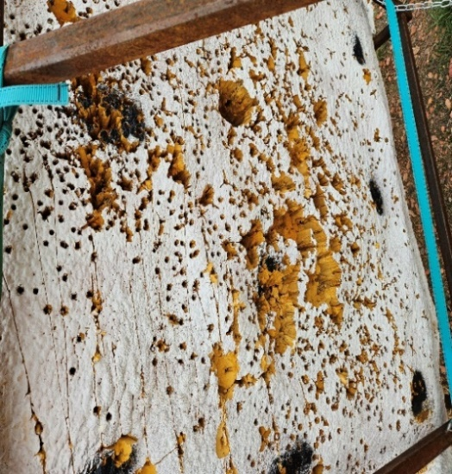

**2. The 3D Animals**

The 3D animals are replicas of animals who can be hunted for food and sport. The animals are made of foam and have scoring rings marked to show what score you would get based on where your arrow lands. These targets are used for our 3D fun night, for target practise and our school classes. They are very popular with our drop-in programs as well. They have heavy usage in the key high scoring areas of the target. Many of our 3D animals have expired. Broken legs, centres shot out and are unrepairable. New targets can now be purchased with replaceable centres extending their lifespan significantly. We require 55 new targets for our drop in 3D area and 15

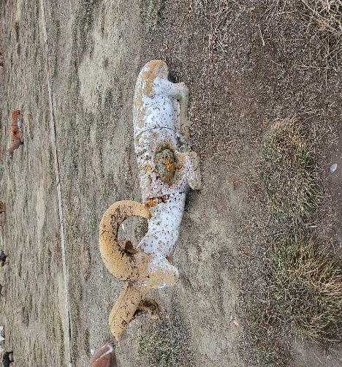

for our 3D course. The pictures below show the following. The bedded ram with the centre shot out represents targets on the 3D range.

**3. Olympic Targets for 720 Competition**

720 Rounds are ones in which the shooter shoots 72 arrows consecutively at a target face of a maximum score of 10. As the distance of the closest target is 55 meters the target faces are quite large and take up most of the target face. This is why the centres get shot out. As finances are minimal, we used a target made up of layers of wood chip material stacked on each other. The challenge with these is once the centre is shot out you need to replace the middle stack which is difficult and requires a front-end loader and is tricky. In addition, the target does not weather well and becomes too tight and sticky. Arrows are extremely difficult to remove and a more modern and easily replaced system is required. We wish to experiment with 3 new target faces. These targets were all removed in 2024 and have yet to be replaced.

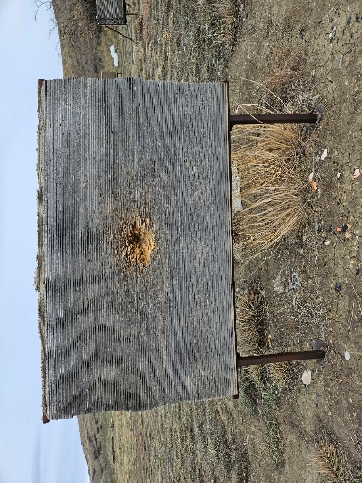 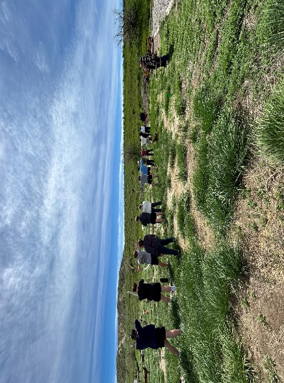

**Maintenance Items**

In 2024 we purchased a number of storage and shelving units for inside our storage shacks. This has helped reduce some of our mouse problems. We procured necessary tools and apparatus to maintain the range and its operations.

**Repairs and Replacement**

**Current Inventory**

**White Targets 20 –** Status 10 unusable and we are attempting to sell them. 10 new targets in 2024 and have been shot out and in need of repair. 10 targets from a few years ago in need of repair. All white targets are either at the end of their lives or in need of repair.

**3D animal targets**– Status 15 unusable and will be discarded in 2025, 8 at 35% lifespan, 10 in good shape. In 2024 20 new animals were purchased which is approximately ½ of what we need.

**Olympic Targets –** Status No targets - need to be replaced.

**Grant Programs 2024**

**ACA Grant Application**

Total Required $37,130.00 [Attachment A illustrates the detail of the financial need] note funding is allocated in thirds.

**Special Notice…This grant has been approved and 2/3rds received**

**City of Lethbridge Grant**

The City of Lethbridge has a Community Capital project grant that archery will apply for. A motion by LFGA was accepted allocating $20,000 in matching funds. As we just received ACA grant funding in the amount of $37,130.00 we will apply that to the grant as well. The city grant request will be for $28,429.00. Note funding is allocated

**Special Notice…This grant has been approved funding has not been received. There will be a 15% holdback on this grant.**

**Revenues 2024**

White targets possible $125

FITA targets $ 0

3D Field Course Tuesday Night $600

**Total Revenue $725**

**Revenues 2025 Projected**

Old White target sales possible $200

3D Field Course $700

One 3D Competition $800

**Total Revenue $1700**

**It should be noted until we have all of our targets any competitions to generate significant revenues are limited.**

**Reminder our youth and intro programs are all free.**

**LFGA Archery 2024 and Beyond**

In 2024 we received 50% of our funding and have purchased approximately ½ off our allotted targets. We hope to receive all of the funding in 2025. Attachment A reflects our program with expenses and revenues.

**LFGA Archery 2025**

We have applied for additional ACA funding in the amount of with the money to help finish our range targets and acquire a Zero Turn Mower to cut grass around our targets to mitigate our issues with rattlesnakes we cannot see in the tall grass. This grant is predicated on a financial contribution of $6000 dollars from LFGA and a grant amount of $26,000.

**Attachment A**

|  |  |  |  |  |  |  |
| --- | --- | --- | --- | --- | --- | --- |
| **CITY GRANT APPLICATION LFGA** | | | | | | |
|  |  |  |  |  |  |  |
| **Item** |  | **Unit Cost** |  | **Number** |  | **Total** |
|  |  |  |  |  |  |  |
| **Archery Block Targets** |  |  |  |  |  |  |
| **New White Foam Targets** |  | **$ 550.00** |  | **10** |  | **$ 5,500.00** |
| **Repair White Foam Targets** |  | **$ 100.00** |  | **20** |  | **$ 2,000.00** |
| **FITA Olympic Targets** |  | **$ 2,650.00** |  | **6** |  | **$ 15,900.00** |
| **Includes delivery, Gst, handling** |  |  |  |  |  |  |
|  |  |  |  |  |  |  |
| **Total Foam and Olympic** |  |  |  |  |  | **$ 23,400.00** |
|  |  |  |  |  |  |  |
| **3D Animals /ASA Markings** |  |  |  |  |  |  |
| **Pinnacle Mule Deer** |  | **$ 550.00** |  | **2** |  | **$ 1,100.00** |
| **Pinnacle XL Large Deer** |  | **$ 710.00** |  | **2** |  | **$ 1,420.00** |
| **Pinnacle Pronghorn** |  | **$ 450.00** |  | **2** |  | **$ 900.00** |
| **Medium Black bear** |  | **$ 610.00** |  | **2** |  | **$ 1,220.00** |
| **Howling Wolf** |  | **$ 450.00** |  | **2** |  | **$ 900.00** |
| **Wild Boar** |  | **$ 475.00** |  | **2** |  | **$ 950.00** |
| **Big Horn Sheep** |  | **$ 775.00** |  | **3** |  | **$ 2,325.00** |
| **Strutting Turkey** |  | **$ 455.00** |  | **2** |  | **$ 910.00** |
| **Standing Bear** |  | **$ 775.00** |  | **2** |  | **$ 1,550.00** |
| **Grizzly Bear** |  | **$ 1,525.00** |  | **1** |  | **$ 1,525.00** |
| **Caribou** |  | **$ 1,620.00** |  | **2** |  | **$ 3,240.00** |
| **Black Panther** |  | **$ 450.00** |  | **2** |  | **$ 900.00** |
| **Mountain Lion** |  | **$ 640.00** |  | **2** |  | **$ 1,280.00** |
| **Moose** |  | **$ 2,360.00** |  | **1** |  | **$ 2,360.00** |
| **Javelina** |  | **$ 390.00** |  | **2** |  | **$ 780.00** |
| **Lynx** |  | **$ 450.00** |  | **2** |  | **$ 900.00** |
| **African Lion** |  | **$ 1,410.00** |  | **2** |  | **$ 2,820.00** |
| **Bison** |  | **$ 2,320.00** |  | **1** |  | **$ 2,320.00** |
| **Elk** |  | **$ 1,850.00** |  | **2** |  | **$ 2,700.00** |
| **Wolf** |  | **$ 650.00** |  | **2** |  | **$ 1,300.00** |
| **African Impala** |  | **$ 550.00** |  | **1** |  | **$ 550.00** |
| **Chamois** |  | **$ 600.00** |  | **1** |  | **$ 600.00** |
| **African Hyena** |  | **$ 450.00** |  | **1** |  | **$ 450.00** |
| **AOUDAD** |  | **$ 710.00** |  | **1** |  | **$ 710.00** |
| **Black Buck** |  | **$ 625.00** |  | **2** |  | **$ 1,250.00** |
| **Coyote** |  | **$ 400.00** |  | **1** |  | **$ 400.00** |
| **Wolverine** |  | **$ 390.00** |  | **1** |  | **$ 390.00** |
| **Hill Country Grazing Doe** |  | **$ 450.00** |  | **1** |  | **$ 450.00** |
| **Hill Country Whitetail** |  | **$ 450.00** |  | **1** |  | **$ 450.00** |
|  |  |  |  |  |  |  |
| **Total Number of 3D targets** |  |  |  | **48** |  | **$ 36,650.00** |
|  |  |  |  |  |  |  |
| **3D replacement Inserts for Targets** |  | **$ 100.00** |  | **27** |  | **$ 2,700.00** |
|  |  |  |  |  |  |  |
| **3D Animals and inserts Combined** |  |  |  |  |  | **$ 39,350.00** |
| **GST** |  |  |  |  |  | **$ 1,967.50** |
| **Includes delivery, handling** |  |  |  |  |  |  |
| **3D Animals/Inserts Includes shipping and handling** |  |  |  |  |  | **$ 41,317.50** |
|  |  |  |  |  |  |  |
| **Materials** |  |  |  |  |  |  |
|  |  |  |  |  |  |  |
| **Storage Lockers/tables/chairs** |  | **$ 500.00** |  | **8** |  | **$ 4,000.00** |
| **Archery Stands/Holders** |  | **$ 1,453.00** |  | **1** |  | **$ 1,453.00** |
| **Arrows/Bows/Paint/Signage and Construction Materials/Platforms** |  | **$ 5,388.50** |  | **1** |  | **$ 5,388.50** |
| **Includes delivery, Gst, handling** |  |  |  |  |  |  |
| **Materials** |  |  |  |  |  | **$ 10,841.50** |
|  |  |  |  |  |  |  |
| **SEA Cans Storage Units** |  |  |  |  |  |  |
|  |  |  |  |  |  |  |
| **[SEA] Cans delivered** |  | **$ 5,000.00** |  | **2** |  | **$ 10,000.00** |
| **Includes delivery, Gst, handling** |  |  |  |  |  |  |
|  |  |  |  |  |  |  |
| **CITY GRANT Financial Reconciliation** | | | | | | |
|  |  |  |  |  |  |  |
|  |  |  |  |  |  |  |
| **Total Foam Block/FITA Targets** |  |  |  |  |  | **$ 23,400.00** |
|  |  |  |  |  |  |  |
| **3D Animals and inserts** |  |  |  |  |  | **$ 41,317.50** |
|  |  |  |  |  |  |  |
| **Materials** |  |  |  |  |  | **$ 10,841.50** |
|  |  |  |  |  |  |  |
| **[SEA] Cans** |  |  |  |  |  | **$ 10,000.00** |
|  |  |  |  |  |  |  |
| **Total Project Cost** |  |  |  |  |  | **$ 85,559.00** |
| **Includes delivery, Gst, handling** |  |  |  |  |  |  |
|  |  |  |  |  |  |  |
| **Balance** | | | | |  | **-0-** |
|  |  |  |  |  |  |  |
| **City of Lethbridge Grant** |  |  |  |  |  | **-$ 28,429.00** |
|  |  |  |  |  |  |  |
| **Lethbridge Fish and Game Association Matching Funding** |  |  |  |  |  | **-$ 20,000.00** |
|  |  |  |  |  |  |  |
| **Alberta Conservation Association Grant Funding Received 2024** |  |  |  |  |  | **-$ 37,130.00** |
|  |  |  |  |  |  |  |
| **Variance** |  |  |  |  |  | $ - |